1.

* **Install Power BI Desktop and share the final screenshot of the report view page which appears when power desktop starts.**

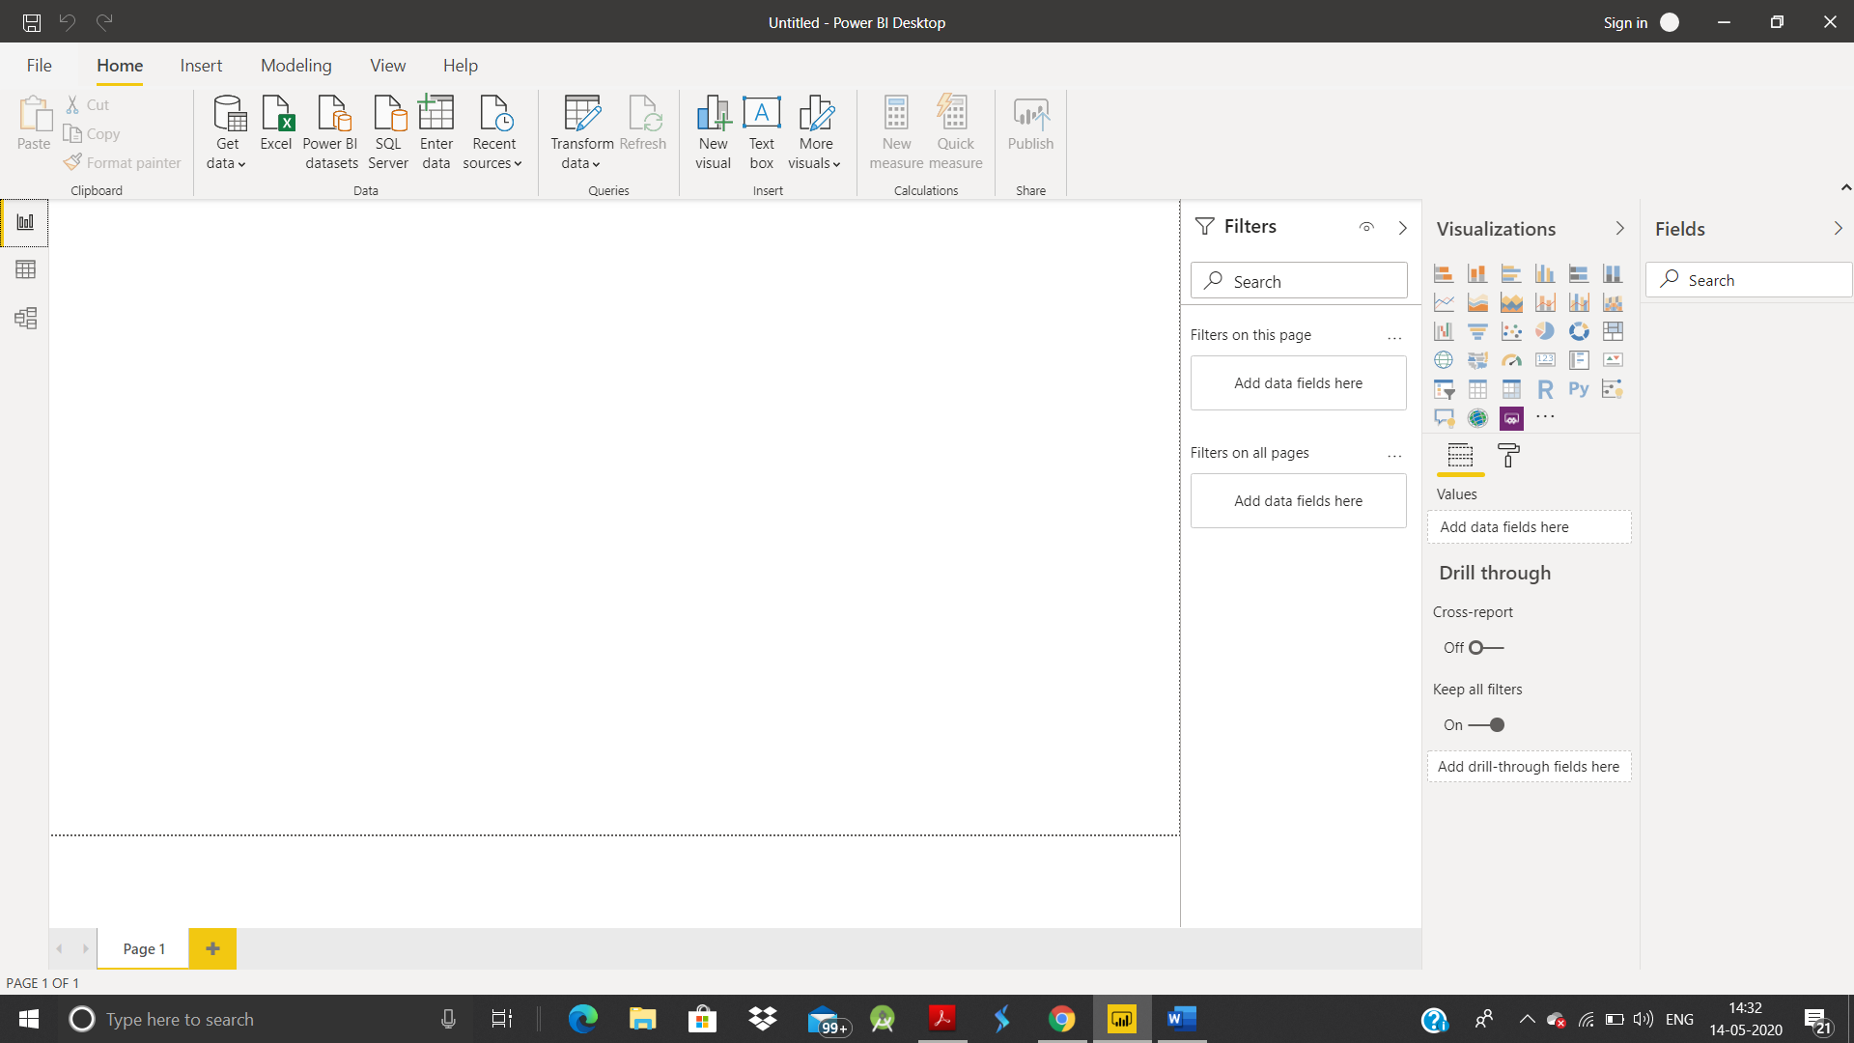

2.

* Prepare a document and with the following screenshot

REPORT VIEW

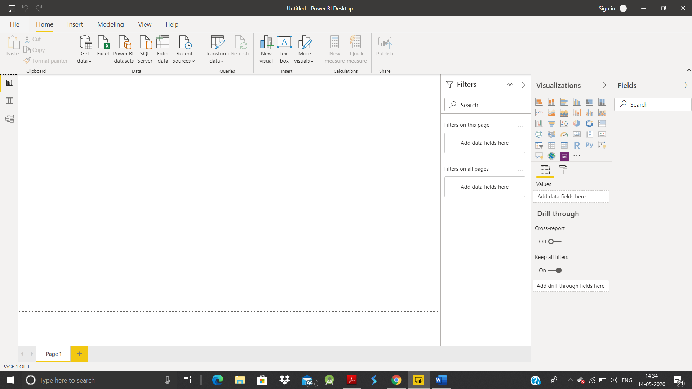

DATA VIEW

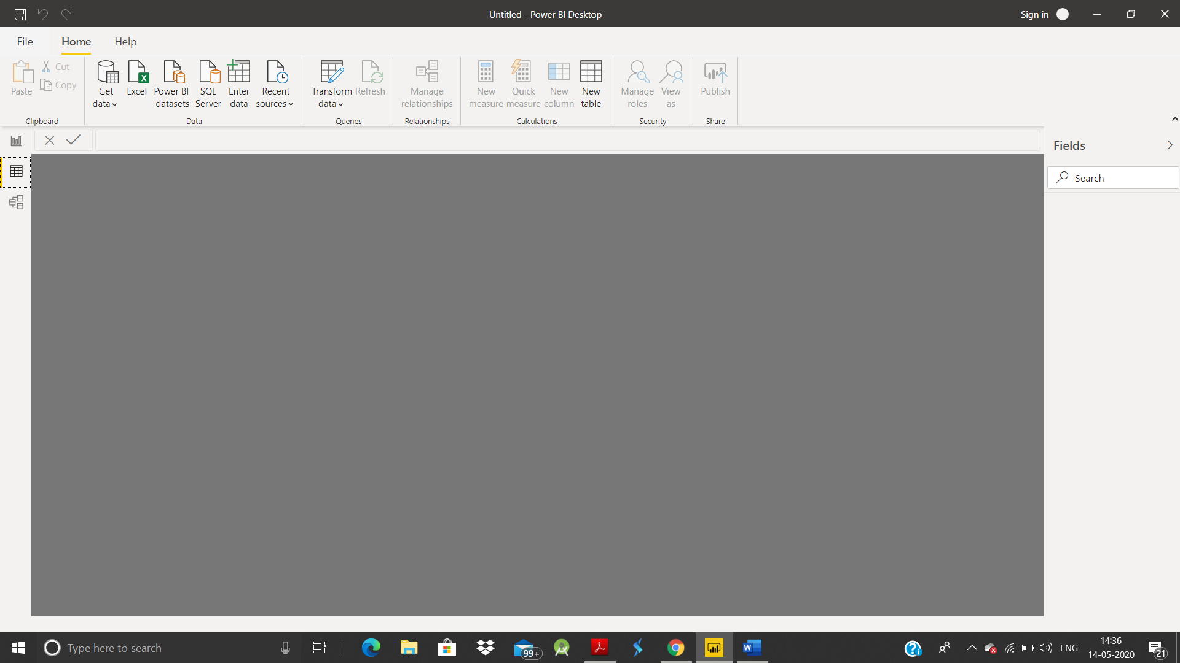

MODEL VIEW

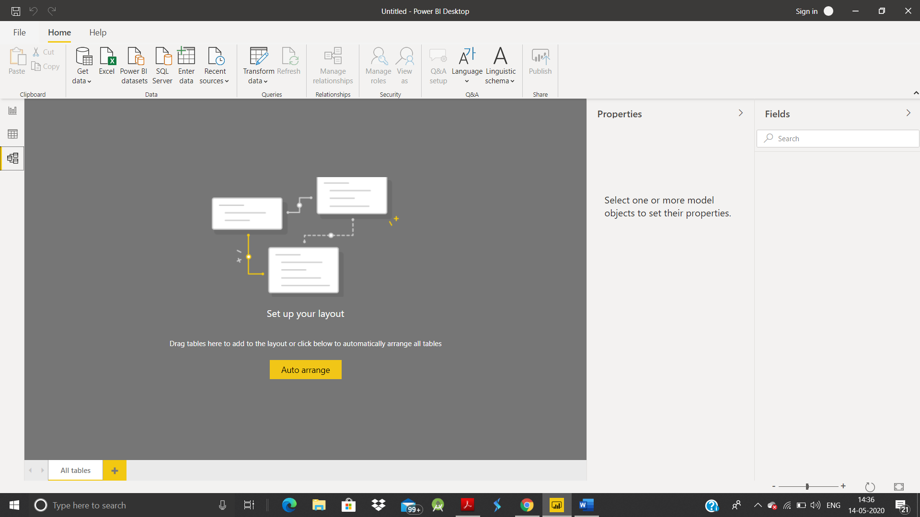

POWER QUERY EDITOR

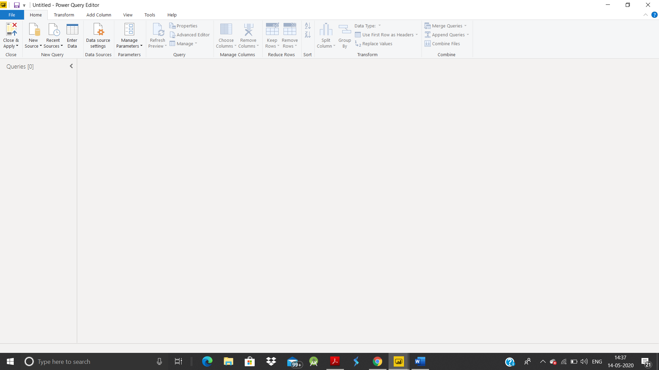

ADVANCE EDITOR

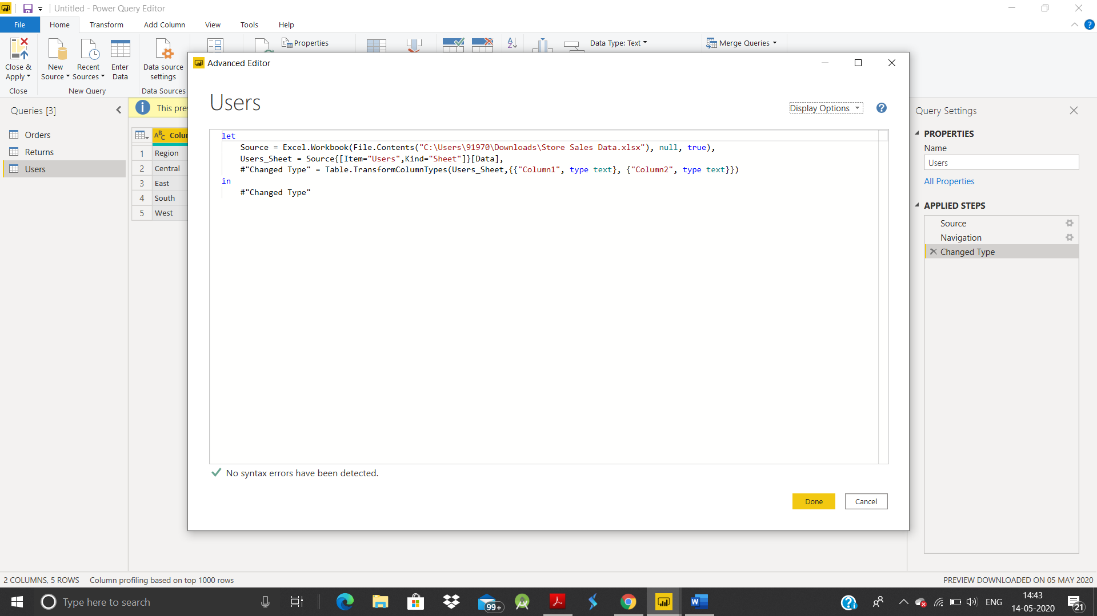

* Prepare a document with details of the following along with their price

POWER BI DESKTOP

POWER BI PRO

POWER BI PREMIUM

Power BI Desktop is a free application you install on your local computer that lets you connect to, transform and visualize data. With Power BI desktop, you can connect to multiple different sources of data, and combine them into a data model.

Power BI Pro is the full version of Power BI, complete with the ability to use Power BI for both building dashboards and reports and unlimited viewing, sharing and consumption of your created reports (and reports shared by others) - the latter not possible with Power BI Desktop.

Power BI Premium is the most expensive tier of Power BI currently available and very distinct from the other two versions available on the market.

Power BI comes in three levels – Desktop, Pro, and Premium. The Desktop level is free for individual users, while the Pro plan costs $9.99 per user per month. The Premium plan starts at $4,995 a month per dedicated cloud compute and storage resource.Jan 2, 2020